Help with iFollow
We have provided the following advice and assistance concerning iFollow. We cannot guarantee that all of the advice will work as everyone has different devices, broadband suppliers and contracts.
However, the information we have obtained is from different sources and will hopefully assist you.
First steps - Registering for iFollow
- Log into your www.cufcdirect.co.uk account or register for an account if you do not have one.
- Confirm the access to CUFC Direct is the same as the one being used for accessing the club website.
- You can edit your personal details by clicking on the My account like on the top of the screen on the right hand side. Using the edit screen button. Confirm your details are correct and amend if required
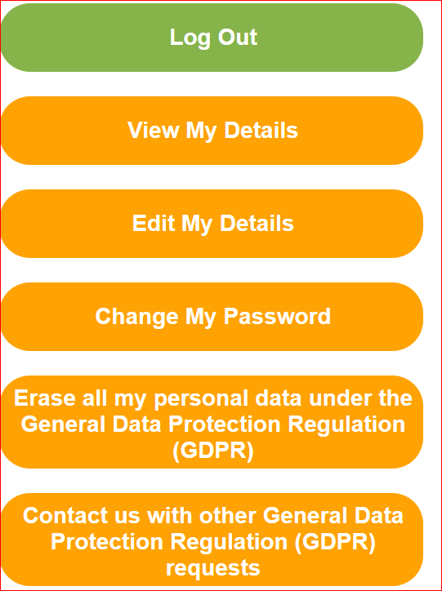
- Log onto your iFollow account on the club website https://www.cambridge-united.co.uk/
- Click onto your name in the navigation bar top right to get to 'My Account page'
Scroll down to Purchased packages.
Click the + sign next to 'Purchased Packages'
If you are a season ticket holder and have been granted access, you will see 'Season Ticket – Cambridge Untied'
- If you are not a season ticket holder, but have purchased individual home or away matches you will see one or more ‘Video Match Pass’ licence names.
If it doesn’t show, then either you have not set up an iFollow account or you are using an email address the club are not holding against your name
On the club website – click on the iFollow tab and use the next match tab from the dropdown
You will see the following. We recommend you sign on at least 30 minutes before the match to avoid the last minute sign on rush and problems. This will also provide you a with a chance to ensure you can obtain the service
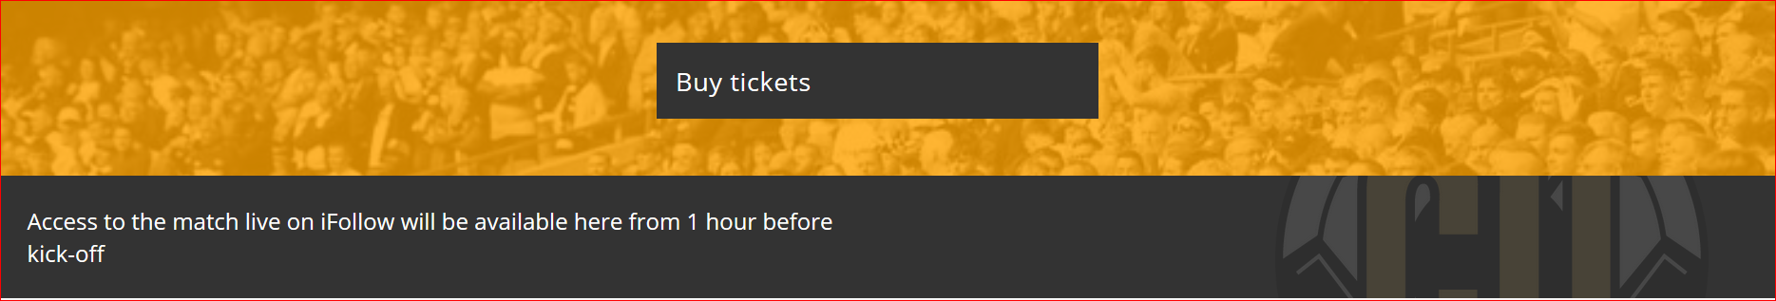

Problems connecting to iFollow via your laptop
Having problems connecting to iFollow on your laptop? Here a few tips:
- Try turning your broadband/Wi-Fi off for 2 minutes to clear the cache about an hour before the match.
- Restart your laptop
- You can connect via Wi-Fi or you can plug an ethernet cable directly into your router and laptop.
Connect to iFollow
- If you are having trouble connecting try changing your browser. You can use Chrome (although a lot of people have reported they have buffering with this) Firefox, Microsoft Edge or Dolphin or try any other browser.
- If you have an Amazon firestick you use Silk
- Check your broadband speed:
  - Type “broadband speed test” in your browser (Chrome, Edge etc or use Google)
  - Select “run speed test”. The test will take under a minute, you are looking for a download speed greater than 20Mbs for a reasonable viewing experience.

The iFollow help page can be found via the link
https://ifollow.zendesk.com/hc/en-us/
- 2020/2021 season https://ifollow.zendesk.com/hc/en-us/categories/360002421158-iFollow-for-the-2020-21-Season
- Season Ticket holder questions see https://ifollow.zendesk.com/hc/en-us/categories/360002427938-Season-Ticket-Holder-Troubleshooting
- General Questions see https://ifollow.zendesk.com/hc/en-us/categories/360002399837-General-Troubleshooting
- Domestic supporters see https://ifollow.zendesk.com/hc/en-us/categories/360000096685-Domestic-Fans
- International supporters see https://ifollow.zendesk.com/hc/en-us/categories/360000096705-International-Fans
You can also email iFollow directly - ifollow@efl.com ifollow@efl.com This should include the reason in the subject line and Cambridge United. In the email provide as much information as possible. For example state the issues being experienced.
If you need to contact ifollow support on match days you can do so by clicking on the envelope at the bottom of the match page. It will open up a chat box. Add your information into the Your Question area. Please provide details of the problem being experienced, any codes and Cambridge United.
Any issues with the service need to be addressed directly to iFollow. They can not be resolved by either the club or CFU
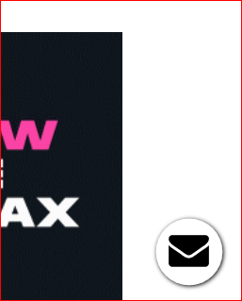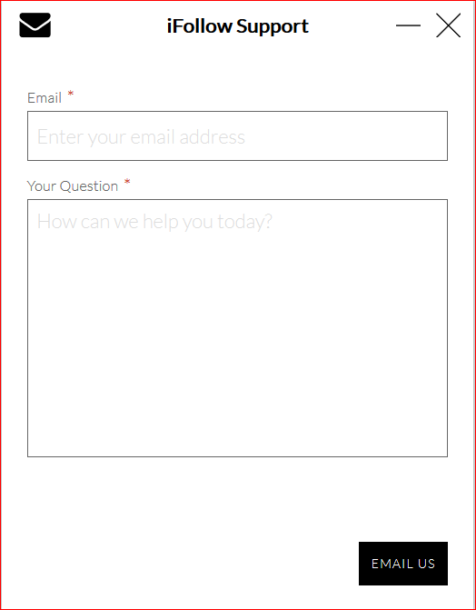

Once iFollow is working
Once you have the iFollow working click on the setting cog at the bottom right of the screen. You will have two things come up: quality and audio.
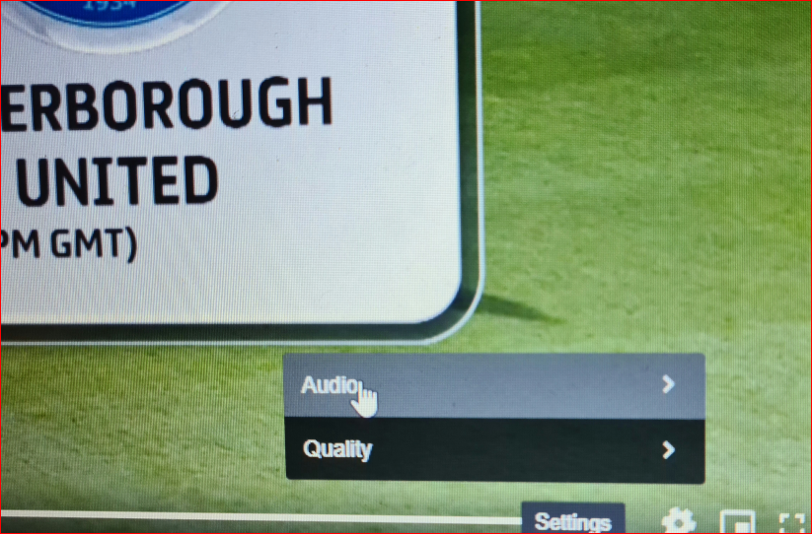

- Click on quality if you have buffering issues (when the action stops or the picture goes blank and you see a rotating circle) then change from “auto” to 504 (there are two 504's you need to top one) or one of the other numbers. The bigger the number the better the quality, so try different settings to get the best picture.
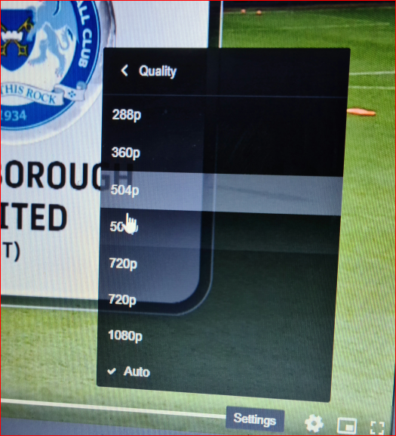

- Click on audio (this is the commentary) you can chose home or away, if we are at home click on home and if we are away click on the away unless of course you want to listen to our opponents commentary. Note that the commentary often doesn’t start until just before (or occasionally after) the match starts, and there are adverts before and at half time when the commentary disappears. There have been occasions when the audio has been of the wrong Cambridgeshire team!
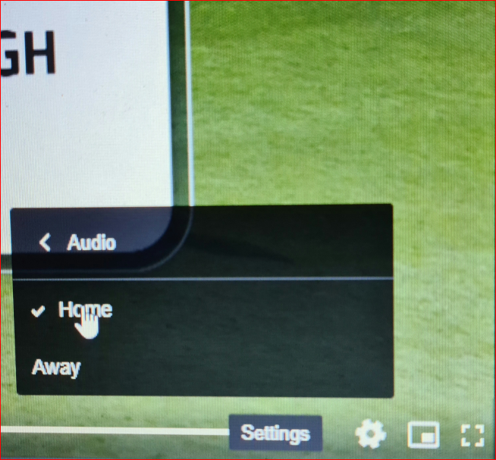
- Watch on full screen to fill your screen with the picture.
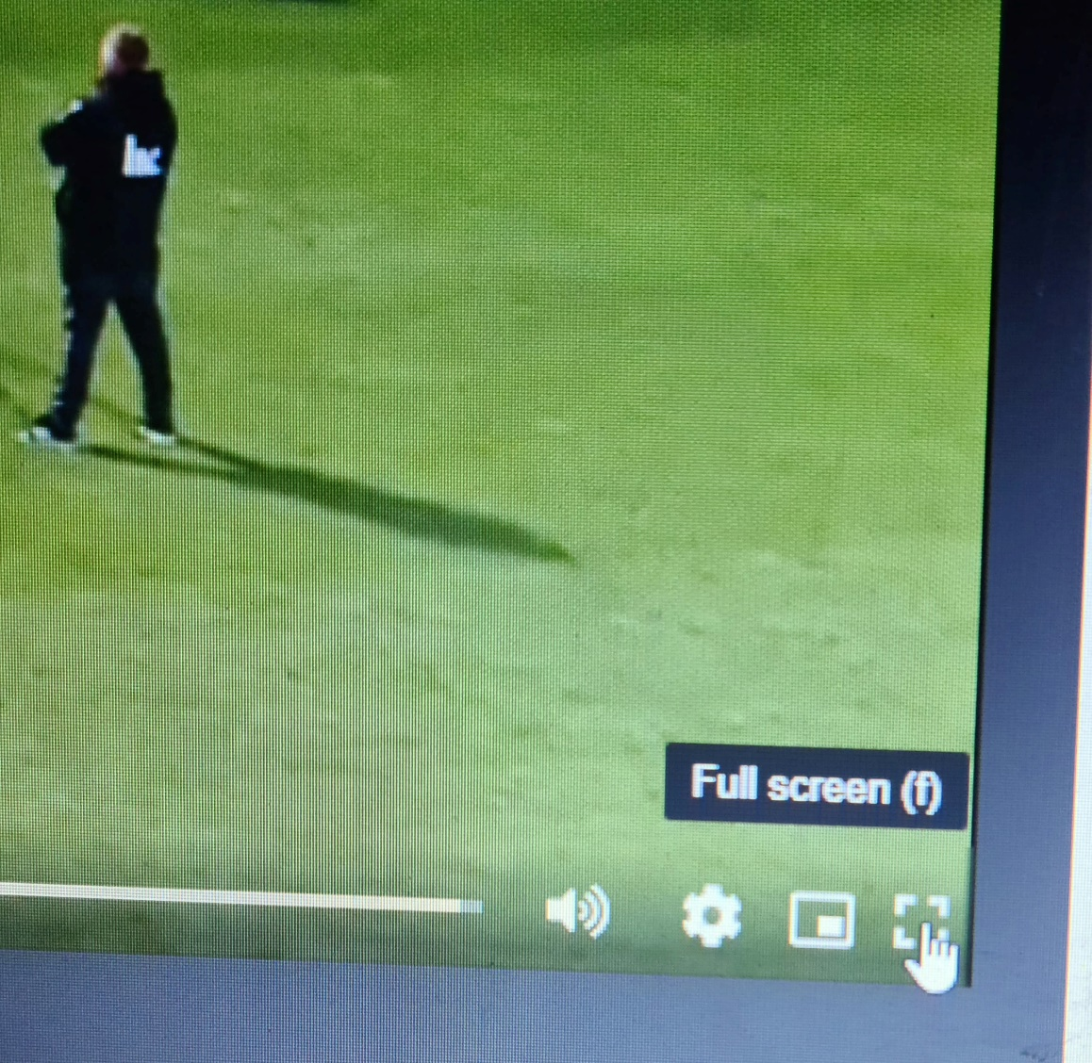
- If you want to watch on your TV connect an HDMI cable from your TV to your laptop. To get a full screen picture click the button on the right of the settings cog.
- To watch on the TV from your phone you will need a smart TV with screen share. Click on the screen share mode on your TV and enable smart view on your phone, your picture from your phone will then be shown on your TV.

Smart Televisions

If supporters are using one of the newest Smart TV models-
- they may be able to simply use "screen mirroring" from their phone or tablet over Wi-Fi.
- Some of the latest Smart TVs are actually computers, and using the TV remote, you may be able to access the internet using the built-in browser and going to https://www.cambridge-united.co.uk and iFollow directly via the device.
- For those with Apple devices, iPhone, iPad, iTouch with iOS 11.4 or later, and Mac with macOS Mojave 10.14.5 or later, you can use direct “screen mirroring” providing the Smart TV has Airplay 2.

Watching iFollow on Apple devices

For those with Apple devices, iPhone, iPad and iTouch with iOS 11.4 or later, and Mac with macOS Mojave 10.14.5 or later, users can “screen mirror” (stream video) from iFollow to your TV via an Apple TV box, noting that you need Apple TV 4K, Apple TV HD, via Apple TV (2nd or 3rd generation) boxes contented to your TV by HDMI cable.

iFollow help

The iFollow help page can be found via the link: https://ifollow.zendesk.com/hc/en-us/
You can also email iFollow directly - ifollow@efl.com <ifollow@efl.com>
If the above doesn’t work out for you it may be because your download speeds need to checked and you may need to check with your service provider
Check your internet speeds
- https://www.ofcom.org.uk/about-ofcom/latest/features-and-news/broadband-checker
Check below for advice on how to stay connected
- https://www.ofcom.org.uk/phones-telecoms-and-internet/advice-for-consumers/stay-connected

Other things we have found
- You cannot use the same code on multiple devices.
- When you are watching you can “pause” or “rewind”:
  - Hover the mouse in the bottom left corner of the picture and select “back 10 seconds”, “Pause” or “forward 10 seconds”/”Live”. (the last will depend on whether you are watching a live game or a recording)
  - For a recording you can use the slide bar at the bottom of the picture to move the action to a particular time
- If you missed the game you can watch the whole game later by going to iFollow and selecting “Latest Videos”
- Check your Wi-Fi reception and speed before accessing iFollow
- Wi-Fi speeds are not the same and slower than Broadband speeds, and dependent upon many factors, reception, location, signal strength and distance between router and device. Best to have device as close as possible to router
- If accessing iFollow via a laptop, connect laptop to router using an ethernet cable for best Broadband speed.

If you have found other features not mentioned please let us know

